Borrower: Mr. Chhim Rapiseth and Mdm. Meas Nakry

1. Mr. Chhim Rapiseth

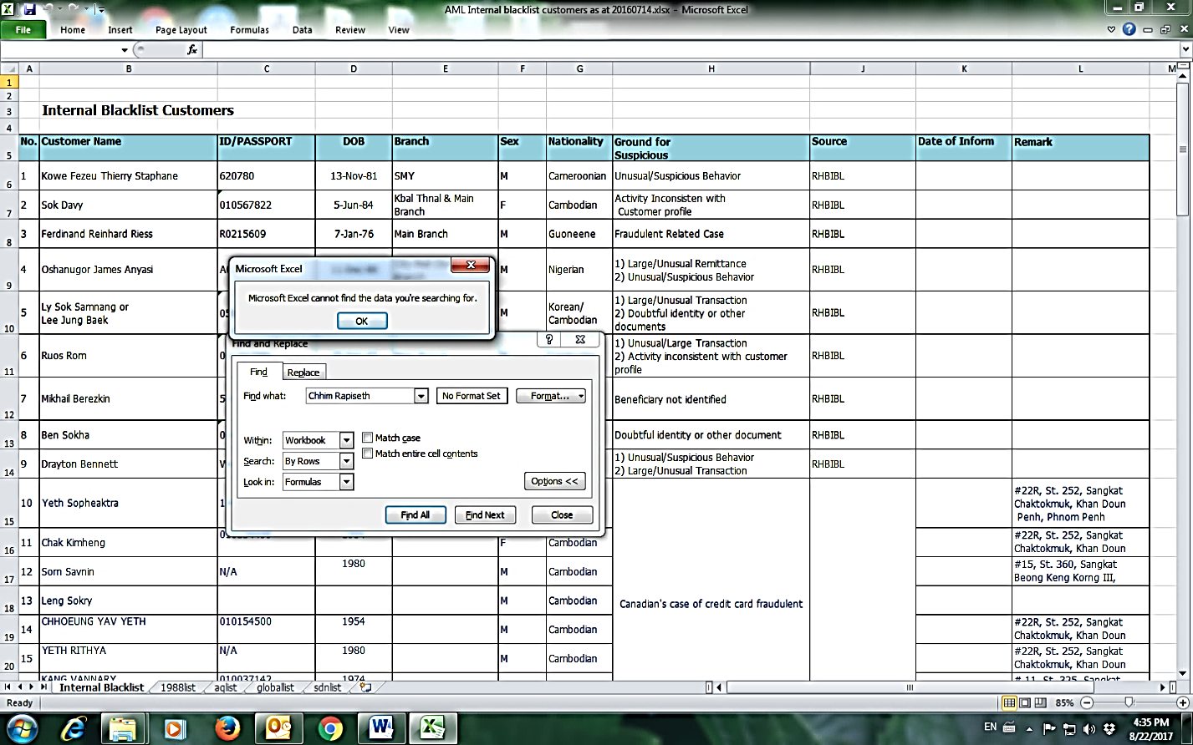

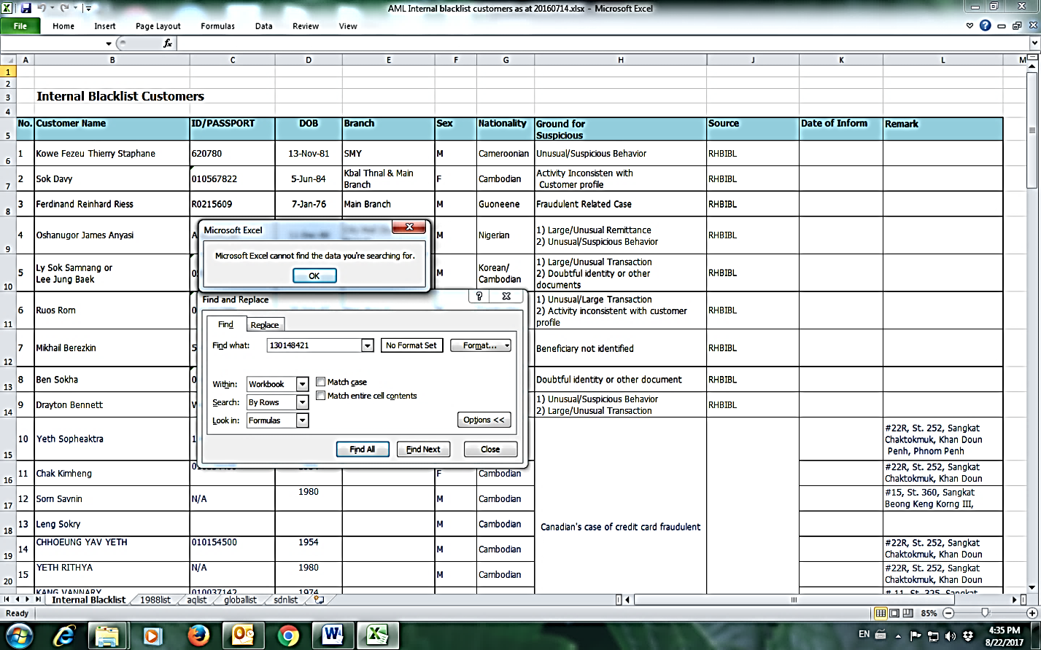

1. Mdm. Meas Nakry

